FarmGame assembly instructions

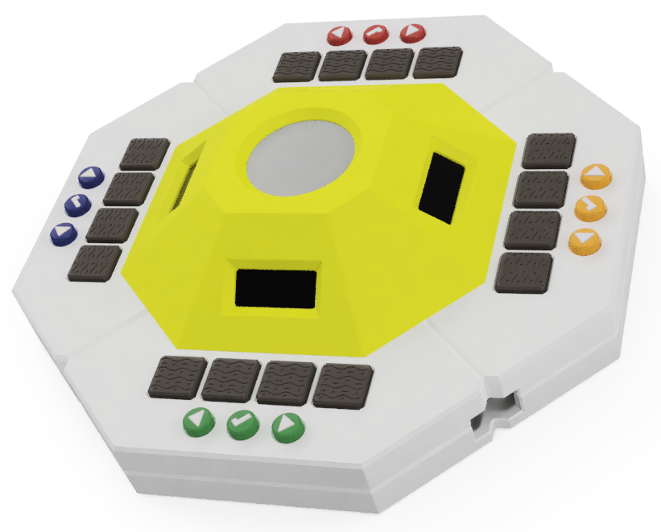

- Ordering the printed circuit board (PCB) from manufacturer
Every FarmGame device has single PCB which contains most of the electronic components. Surface mount (SMT) components are hard to solder so it is required for the manufacturer to assemble the PCBs. Luckily, JLCPCB is a fast, reliable and cheap manufacturer which can do just that but we are not limited to their service, any other manufacturer will do since there are production files available. You can find the gerber files, BOM (Bill of materials) and CPL (Component placement list) in the PCB fabrication folder.
That said, go to jlcpcb.com and create a new quote. Click „add a gerber file“ and select the gerber.zip. Choose PCB quantity 5. On the bottom of the page, enable „PCB assembly“ and select Standard PCBA Type. This feature will enable you to assemble both PCB sides so select the Both Sides as Assembly Side.
Click Next and on the next screen you will see Top and Bottom sides of PCB. Click Next again. Now you will need to upload the BOM and CPL files from the PCB fabrication folder. After that click Process BOM&CPL. Check for errors and click Next. Check for component placement and orientation and click Next to proceed with the quote and finish with the payment process.

- Ordering the rest of the electronical and mechanical components
In the BOM folder you can find the Cost Sheet with complete list of the all parts needed for the FarmGame. The last column contains supplier names and direct links to the catalog on their websites. Choose the required quantity and order all of them.

- 3D printing the parts of enclosure
There are multiple 3D printed parts needed in order to assemble the FarmGame. All the files are available in the 3MF folder. Open the files using your printers slicing software. Here are some guidelines for 3D printing the models for each part of the FarmGame:
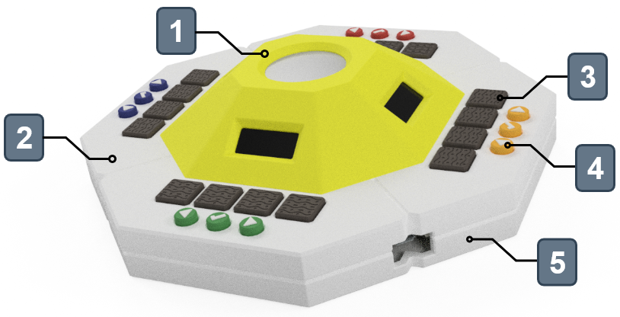
- Upper body part
- Use yellow PLA material
- Use default settings in .3mf file
- Print on textured plate
- Remove support material
- Middle body part
- Use white PLA material
- Use default settings in .3mf file
- Print on textured plate
- Field
- Start printing with GalaxyBlack or similiar PLA material
- When printer pauses for color change use white PLA material
- End print with the same material which you started with
- Use default settings in .3mf file
- Print on textured plate
- Remove support material
- Buttons
- Print 4 different sets of buttons using different colored (red, blue, yellow and green) PLA materials
- When printer pauses for color change use white PLA material
- Print on smooth plate
- Bottom body part
- Use white PLA material
- Use default settings in .3mf file
- Print on textured plate
- Remove support material

- Soldering
Tools and parts:
- 1x PCB with presoldered SMD components
- 12x Push buttons
- 1x Pin strip
- 1x ESP32 microcontroller
- 1x Speaker
- 1x Port expander
- Soldering iron
This part requires some soldering skills in order to solder the push buttons, pin strip and ESP32 microcontroller. Pay attention to which side you need to solder the components on. The push buttons (SW1 – SW12) and pin strip (J5) need to be placed from top side (soldered from the bottom side) – it's the side where the LEDs are soldered on.
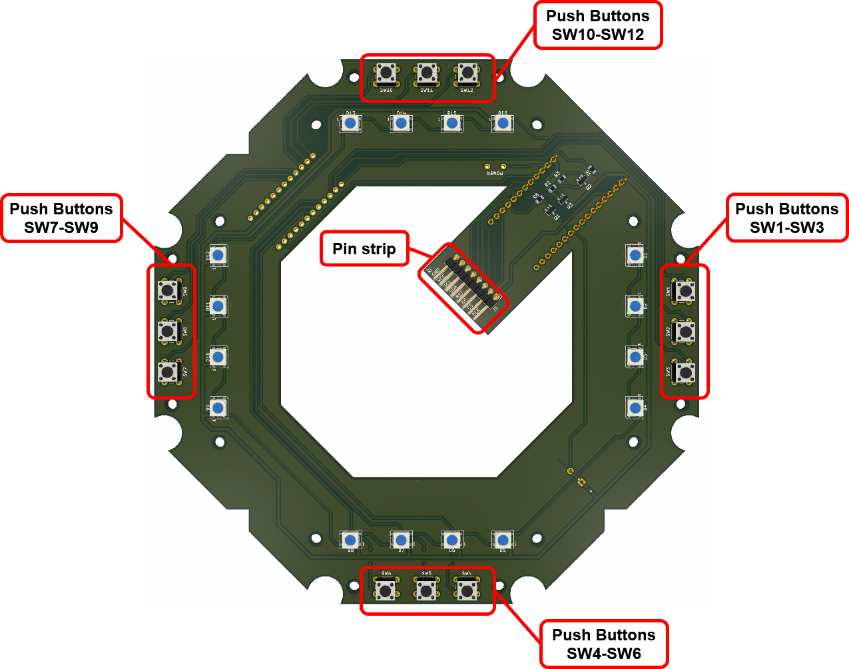
The ESP32 microcontroller, speaker, and port expander must be placed and soldered on the bottom side of the board, the same side as connector J2. The port expander must be oriented in a way that its VIN pin aligns with the hole marked by the white dot.
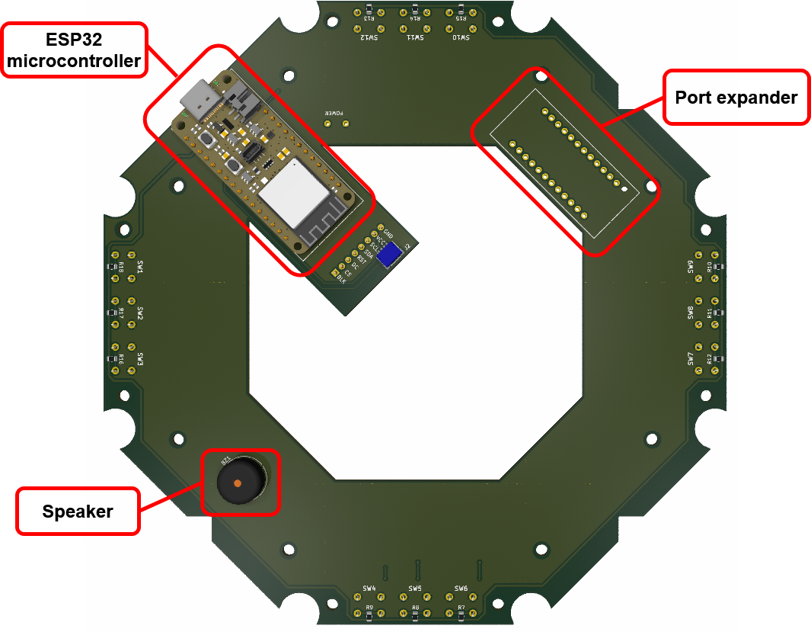

- Installing brass threaded inserts
Tools and parts:
- 36x M2 threaded inserts
- 16x M3 threaded inserts
- Upper body part
- Middle body part
- Soldering iron
Before using screws, the brass threaded inserts must be installed. This is done using the soldering iron, set to a maximum tip temperature of 200 °C. Two sizes of brass inserts are required: M2 and M3. The size difference is obvious—the smaller inserts are M2, and the larger ones are M3. Be careful not to mix them up.
The Upper body part requires 20 M2 inserts marked with blue and 8 M3 inserts marked with red color:
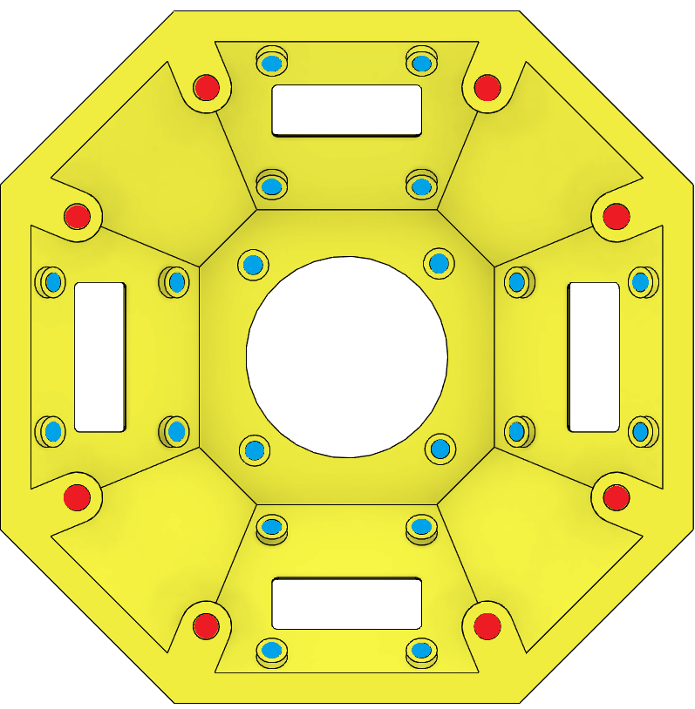

The Middle body part needs 16 M2 inserts marked with blue and 8 M3 inserts marked with red color pressed in using soldering iron:
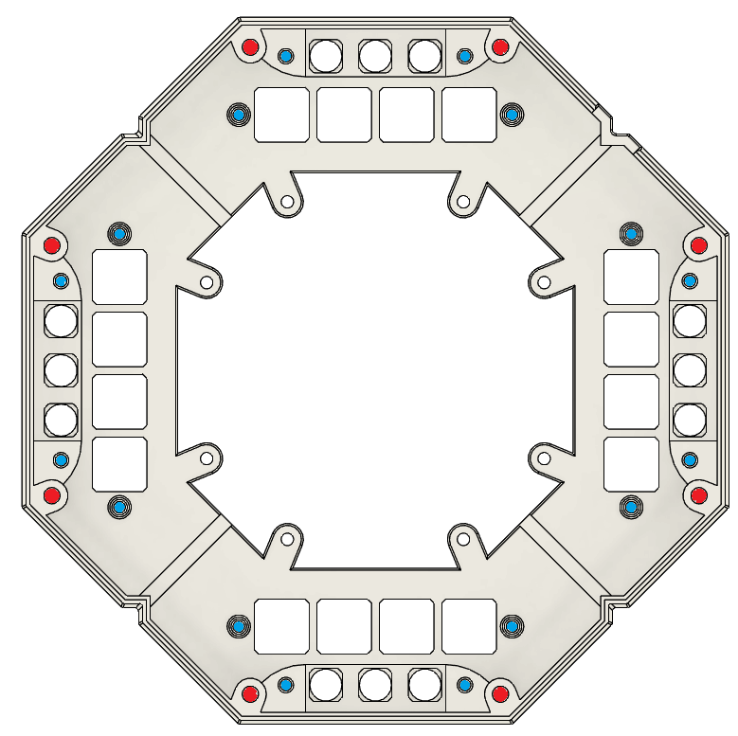

- OLED display jumpers
Parts and tools:
- 2x OLED display
- Soldering iron
Every FarmGame device uses four different OLED displays. To get them to work properly, on two of them the jumper marked as JP6 needs to be shorted using the soldering iron. It should look something like this (notice the yellow arrow indicating the jumper):
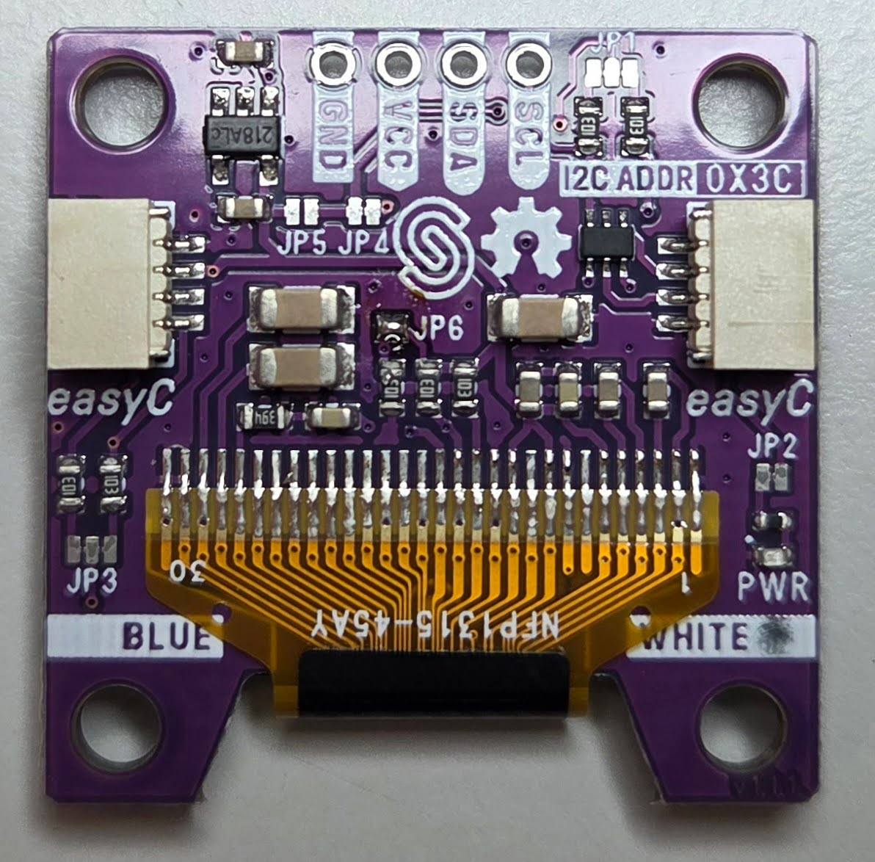

- Upper body part assembly
Parts and tools:
- 20x M2 screws
- 4x OLED display
- 1x GC9A01 display
- Upper body part
- Screwdriver
Two OLED displays with jumpers JP6 shorted need to be mounted in orientation and spots indicated with yellow arrows:

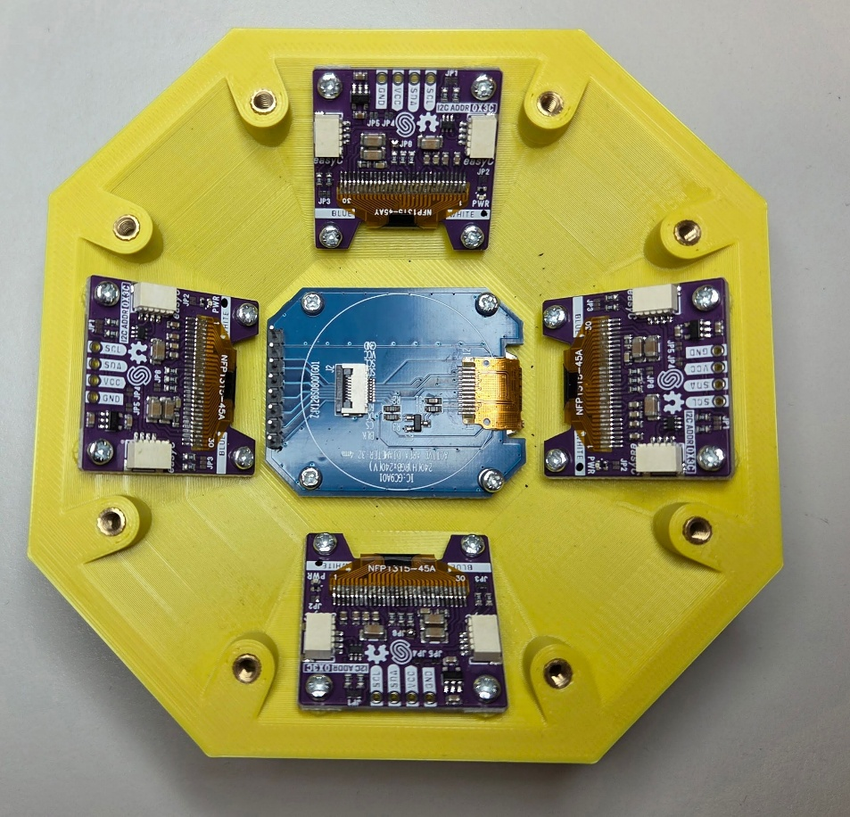
Mount the other two OLED displays and GC9A01 circular display as shown in previous image using the M2 screws (blue arrows). Don't tighten them up to much because there is a risk to crack their screens.

- Wiring displays
Parts and tools:
- 4x 10cm 4-wire OLED cables
- GC9A01 cables (8x female to female jumper cables)
Use the two 10cm 4-wire OLED cables and connect two and two displays according to the following image:

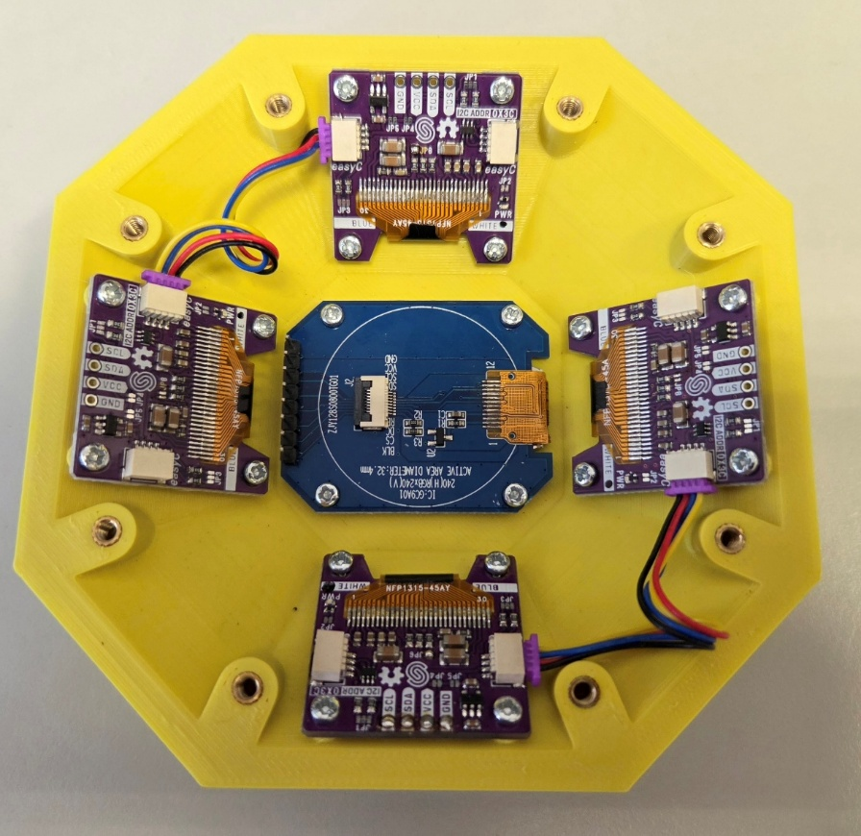

Use the remaining two 10cm 4-wire OLED cables and connect the one end as indicated:

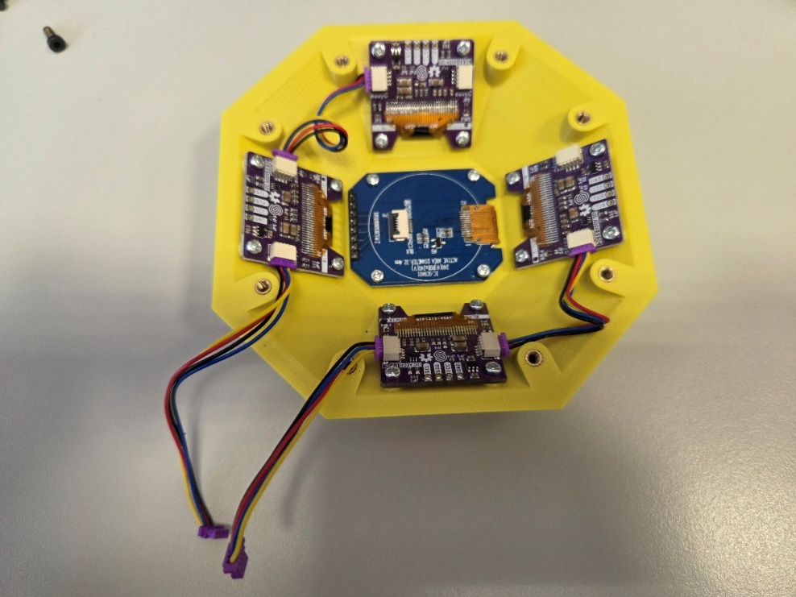
The final step of this wiring process is to connect 8x female to female jumper cables to the GC9A01 display:
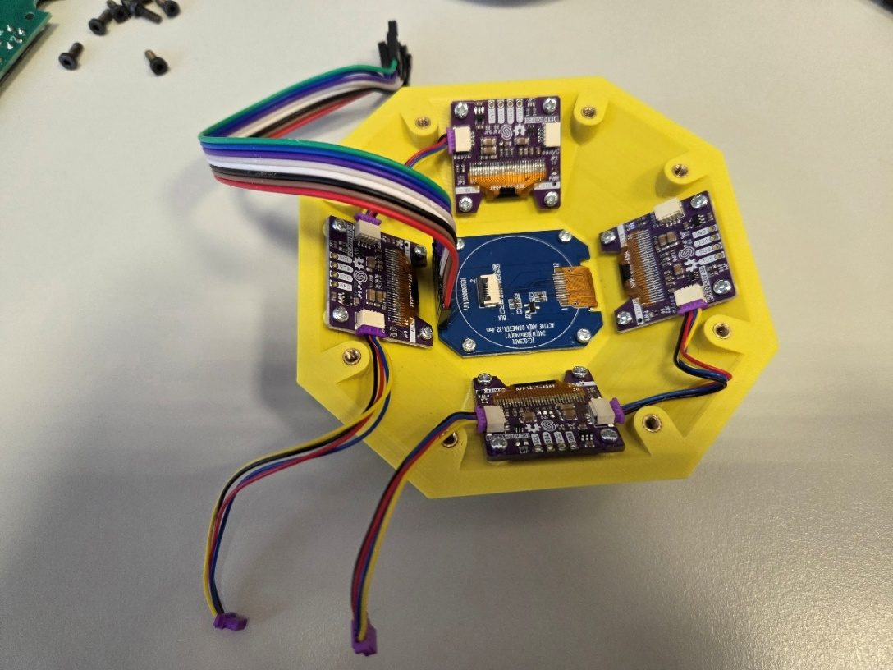

The rest of the wiring job will be done later.

- Middle body part assembly
Tools and parts:
- Player buttons in 4 different colors
- 4x Field parts
- Middle body part
- 16x M2 screws
- 8x M3 HEX screws
- Screwdriver
- HEX screwdriver
Place the player buttons so that the yellow player is located at the bottom, red on the right side, blue at the top and green on the left side. Make sure that the order of the buttons is correct (left, confirm and right button).

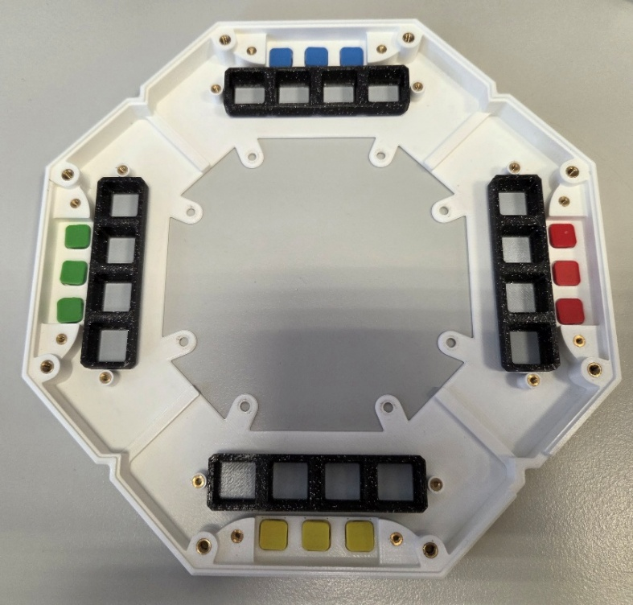

Place the 4 fields, one for each players:
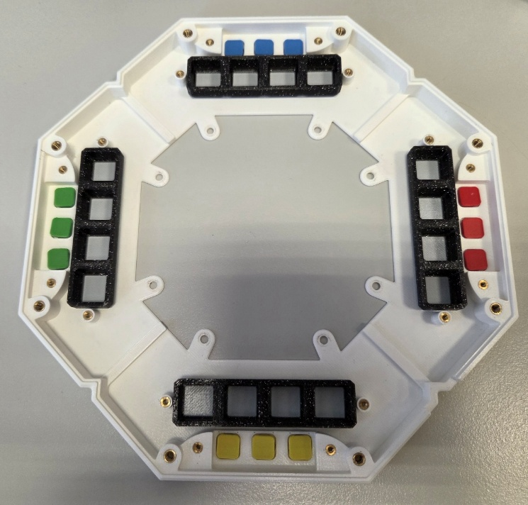
Assemble the upper and Middle body part of the FarmGame using 8 HEX screws.
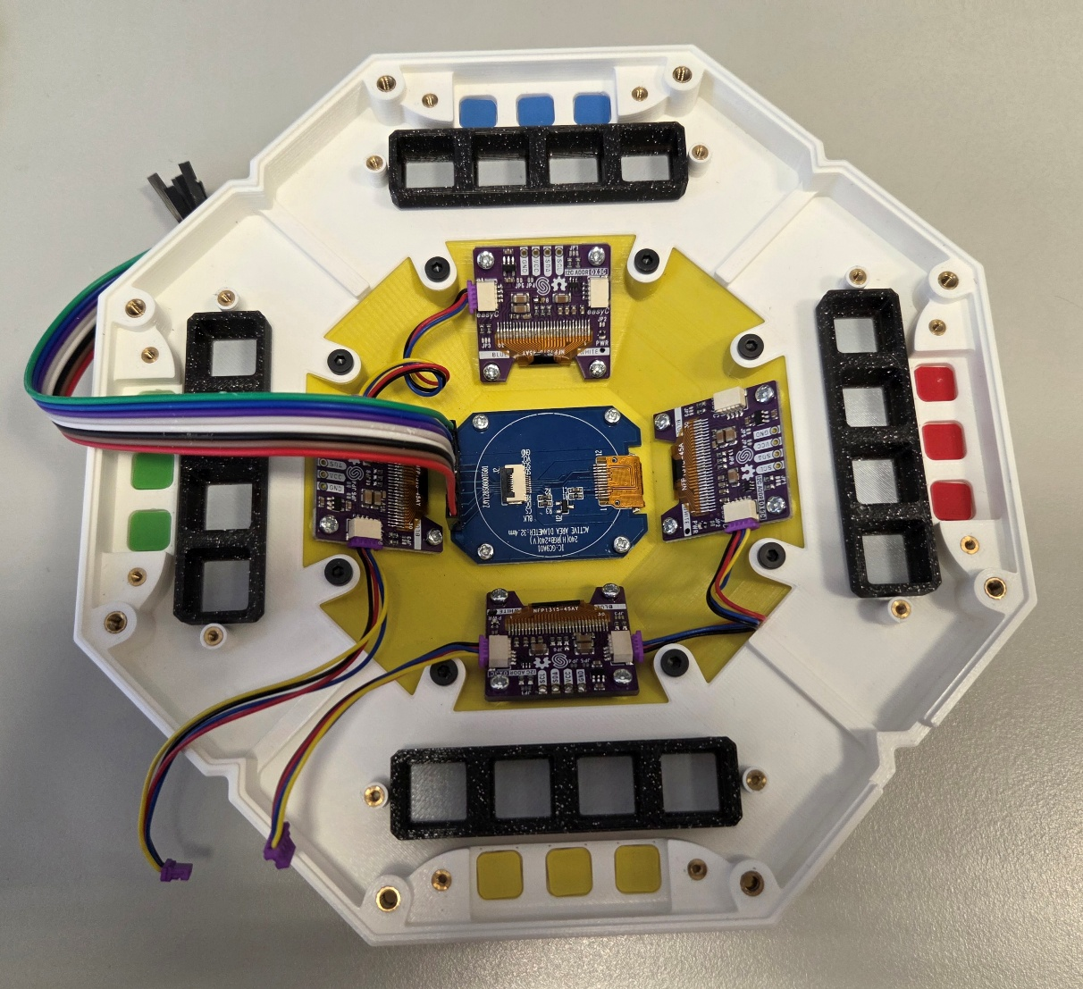

Next, it's time to mount the PCB to the middle body part. Carefully place the PCB on the bottom of the Middle body part and align the holes with threads without moving the previously placed buttons and Fields. Use the 16 M2 screws and screw them in. Try not to overtighten them.
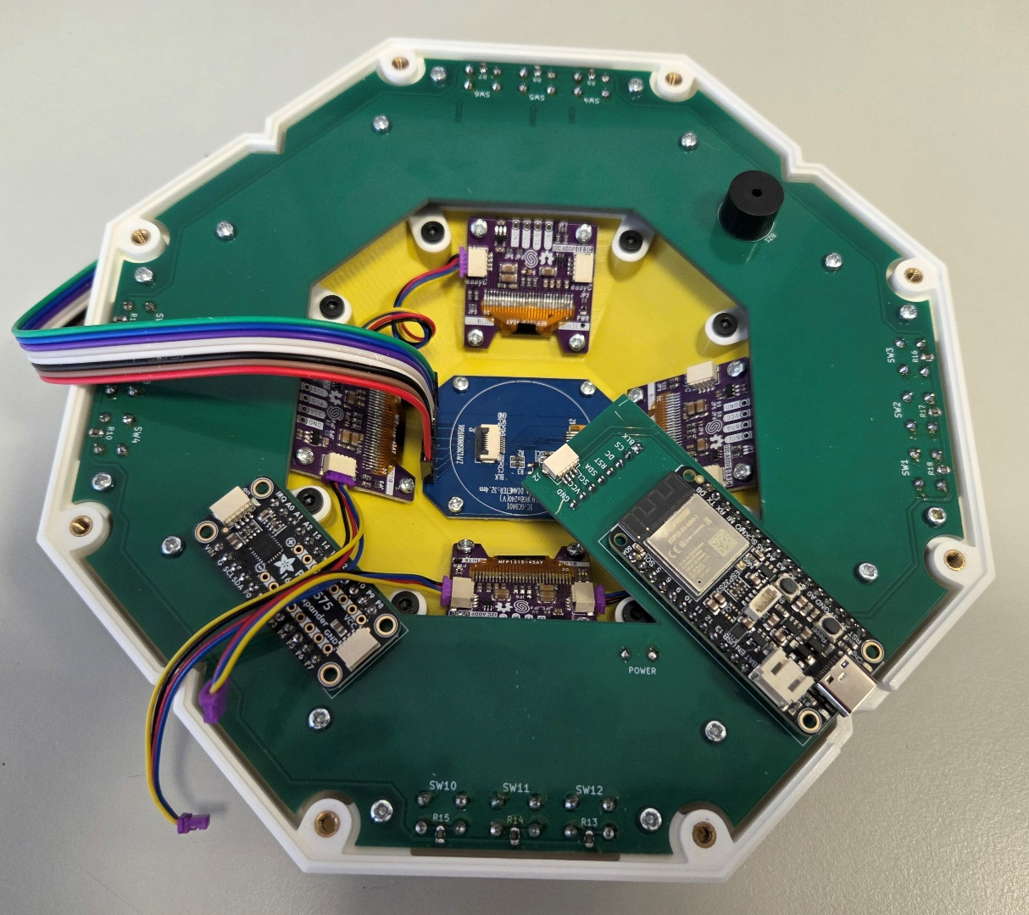

Test every push button if it works properly. If some of them are not going in or out smoothly, try to reduce the torque of closest screw and check again.
Now it's time to finish the wiring process. Connect the three 4-wire cables marked with yellow arrows. The GC9A01 8 pin wires need to be connected with caution (blue arrow). The bottom left wire on the GC9A01 display needs to be connected on the first (top) pin of the PCB, as shown in the following image:
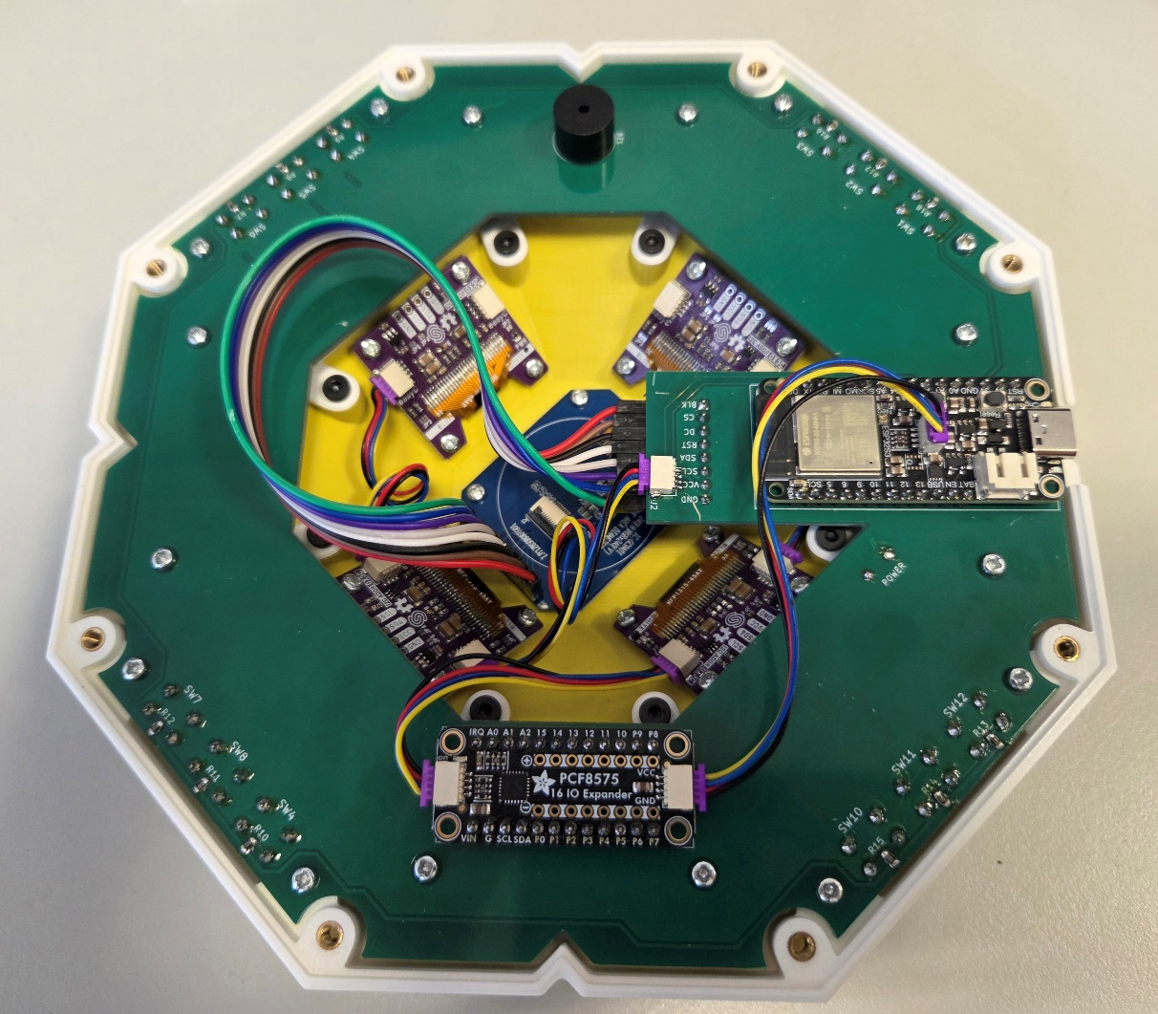

10. Bottom body part assembly
Parts and tools:
- 8x M3 HEX screws
- Bottom body part
- HEX screwdriver
- Rubber feet
- Battery
- Power switch and wires
Insert the power switch into the opening on the bottom housing, then solder the switch and the two wires to the PCB pads labeled “POWER” (indicated by the yellow arrow).
Secure the battery inside the bottom housing using the adhesive tape, and connect it to the microcontroller (as shown by the blue arrow).
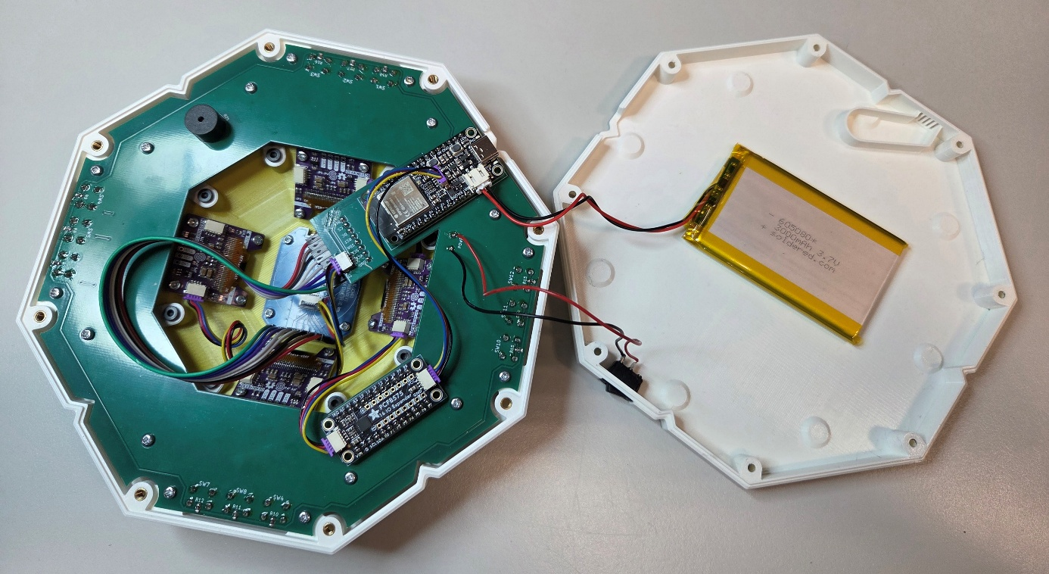
The Bottom body part is just a cover that is attached to the Middle body part using 8x M3 HEX screws. Align the Bottom body part so that the hole for USB cable is properly aligned.
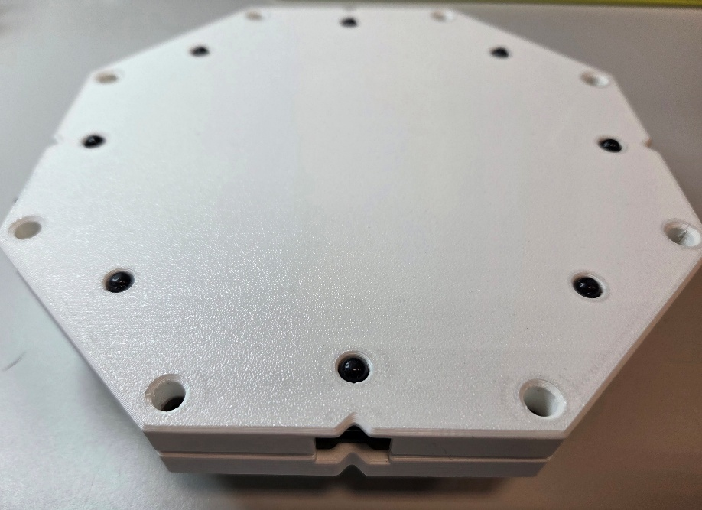

Use the hex screwdriver to tighten the M3 hex screws (indicated by the yellow arrow). Then attach the rubber feet (shown by the blue arrow).

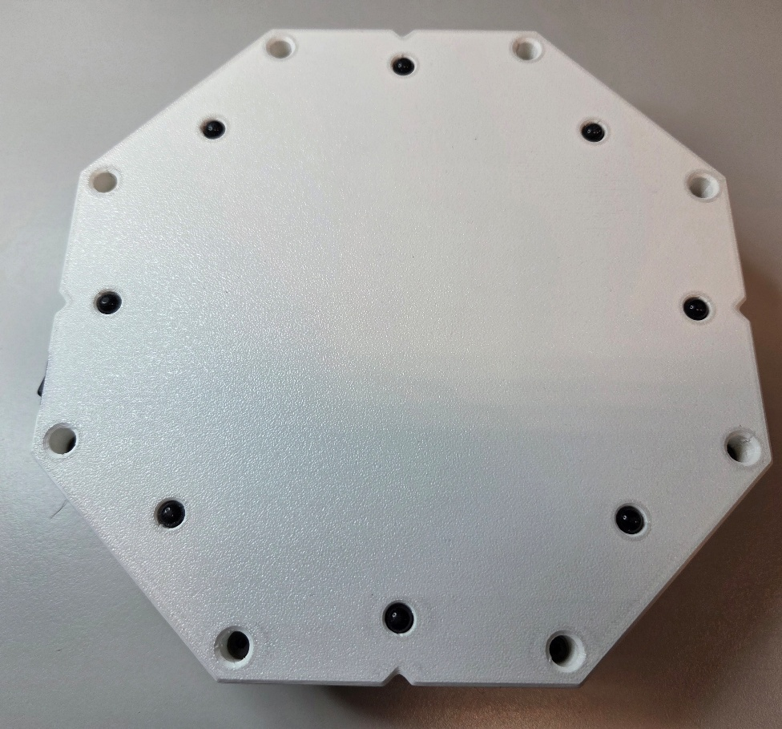

11. Flashing the device
Connect the FarmGame to the PC using the USB-C cable. Download the provided code from the repository and open the project file using Visual Studio Code with installed PlatformIO addon. Compile the code and flash the device.
You are done! The FarmGame will start and you can start testing it! Have fun!

